**Subrata Kumer Paul**

**Roll: 13015411**

**4th year 2nd Semester**

**Session: 2012-13**

**CSE.RU**

**CSE4222: E-Commerce Lab**

**I used** [**https://dbdesigner.net/**](https://dbdesigner.net/) **to design a database.**

1. **Online Address Book**

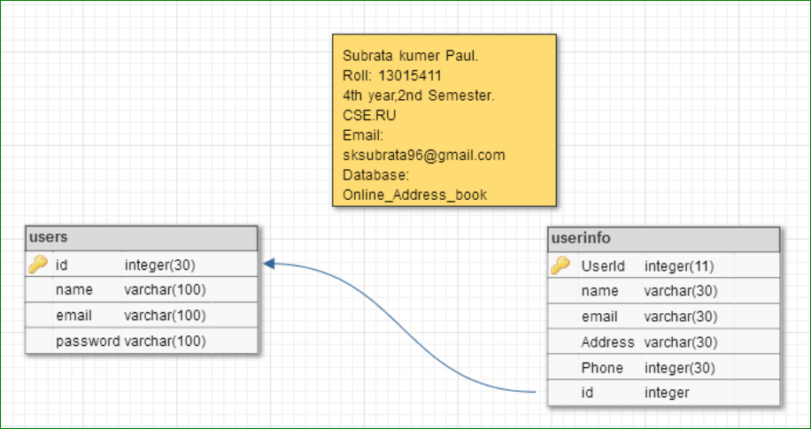

1. **Simple Blog site.**

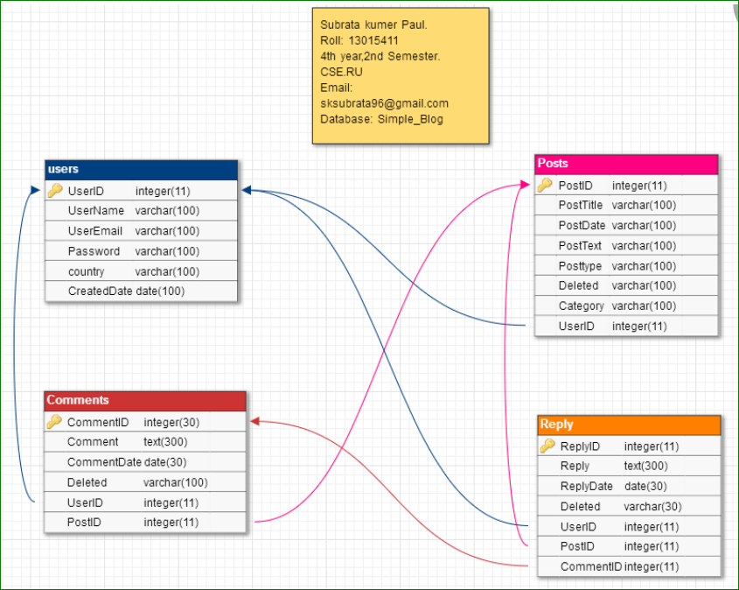

1. **Data Validation**

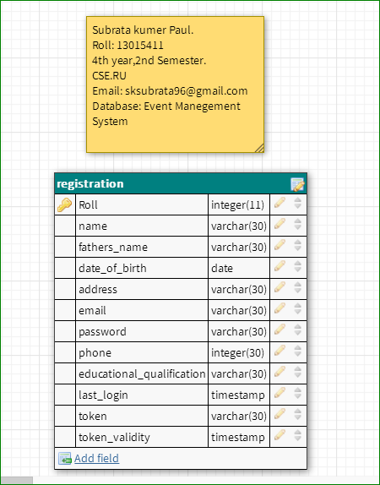

1. **Online shopping**

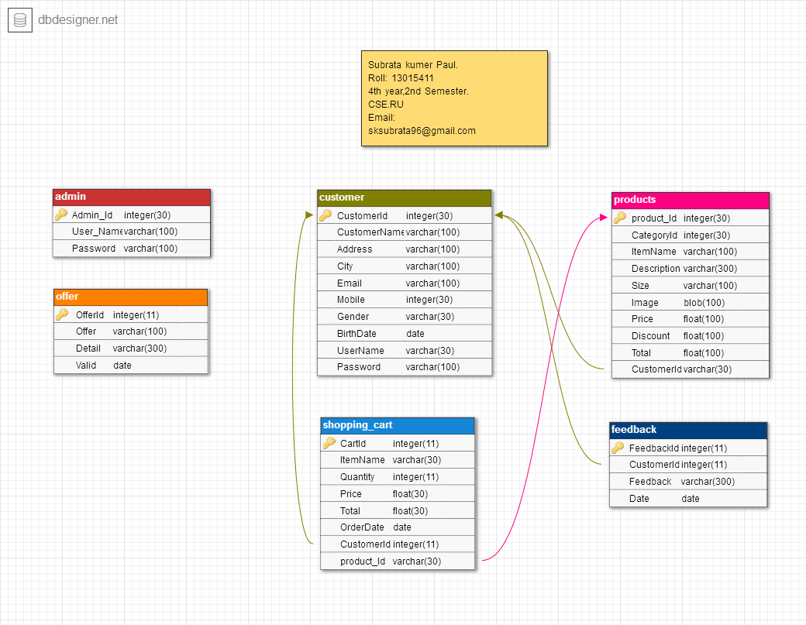

1. **Photos Gallery**

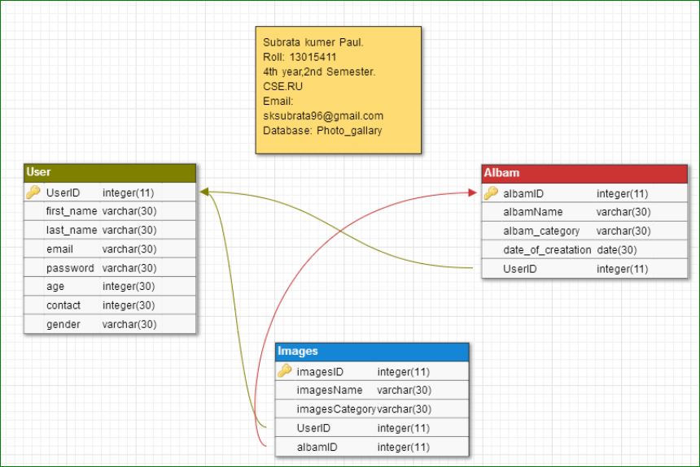

1. **Online Polling System**

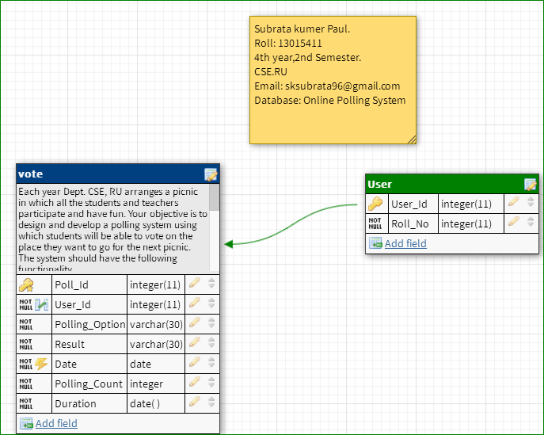

1. **Supplier Oriented B2B – eAuction**

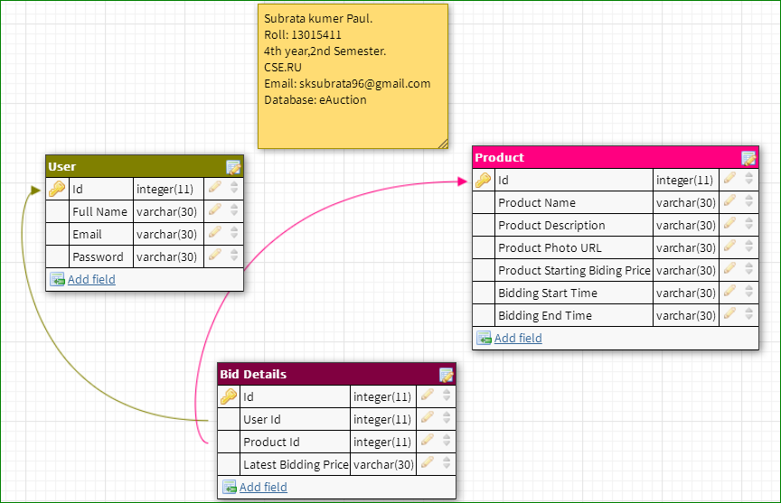

Web Link:

[**https://dbdesigner.net/**](https://dbdesigner.net/)